COMPUTER SCIENCE AND ENGINEERING PROJECT
NAME: MANIS SAHA REG. NO.: 22BCE1538

Title: Image Classification using Convolutional Neural Networks in Python

Code for CNN Model :
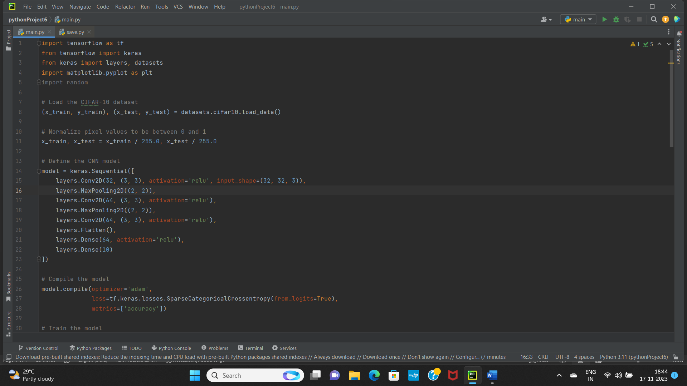
Code for Training and Visualizing the CNN Model :
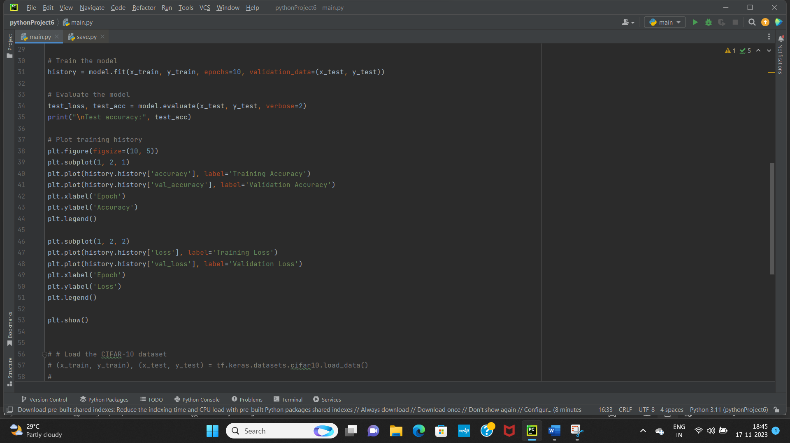
Output for Test Accuracy :

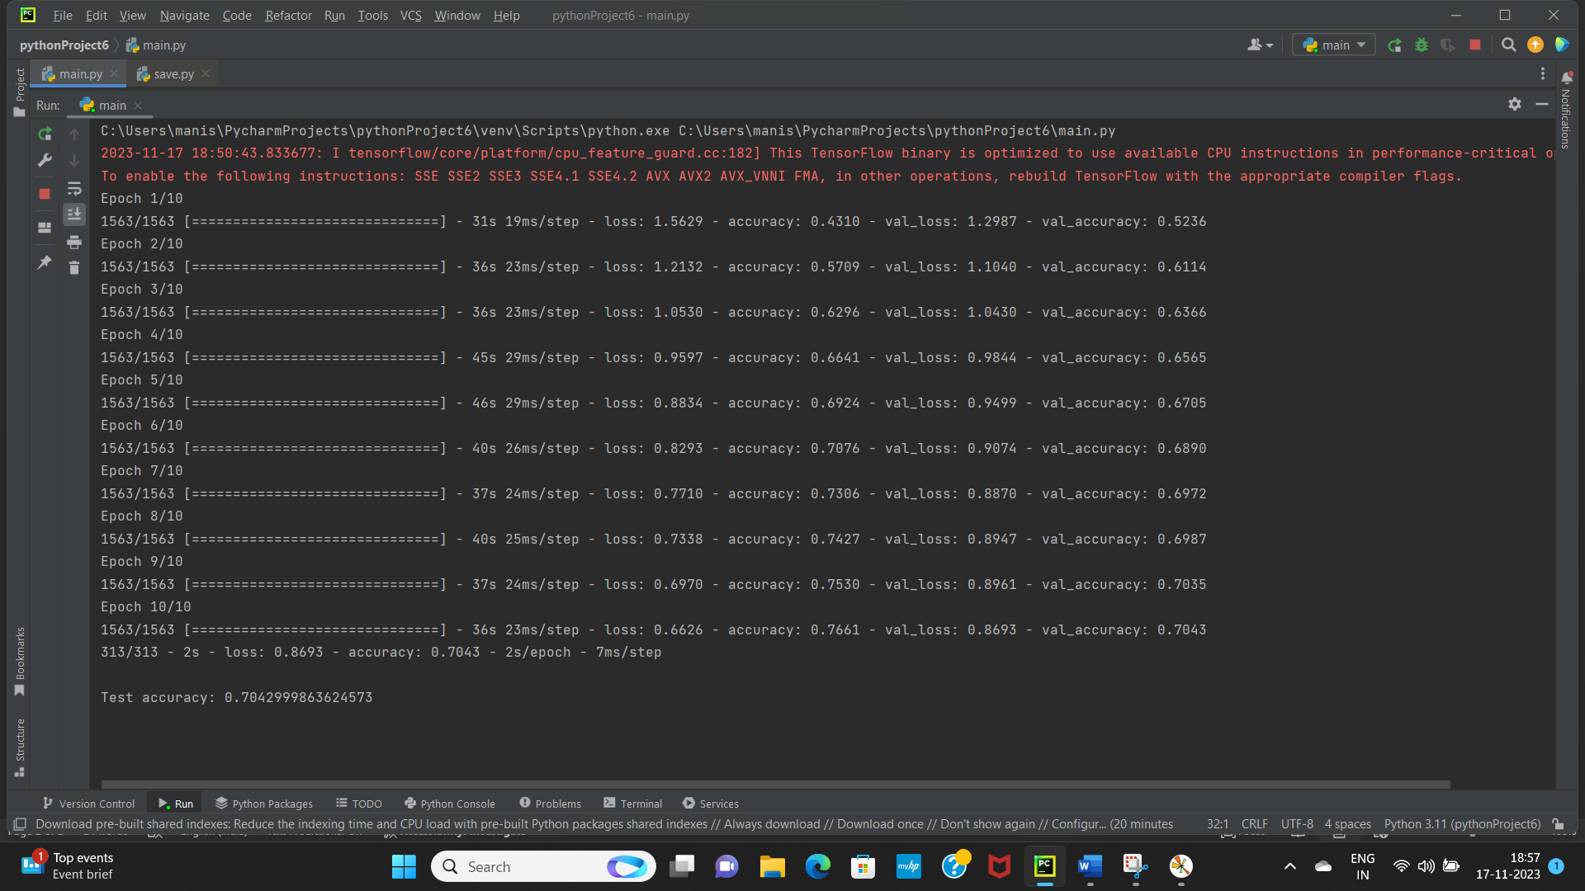
- Comparison between Training Accuracy and Validation Accuracy
- Comparison between Training Loss and Validation Loss
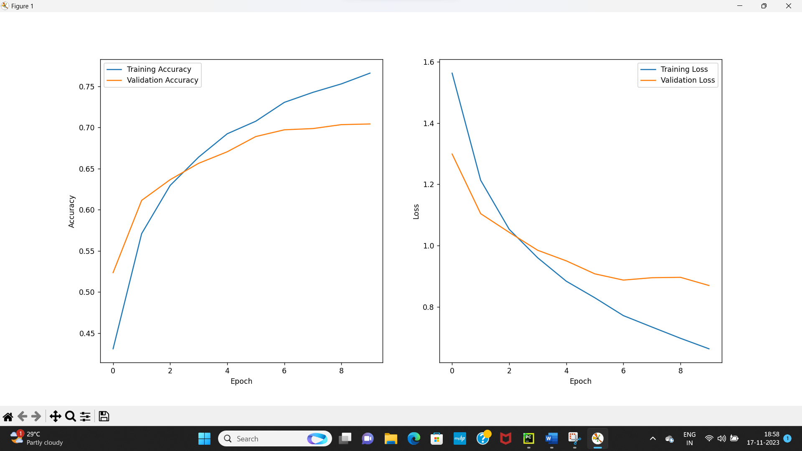

Code for loading the CIFAR-10 dataset :
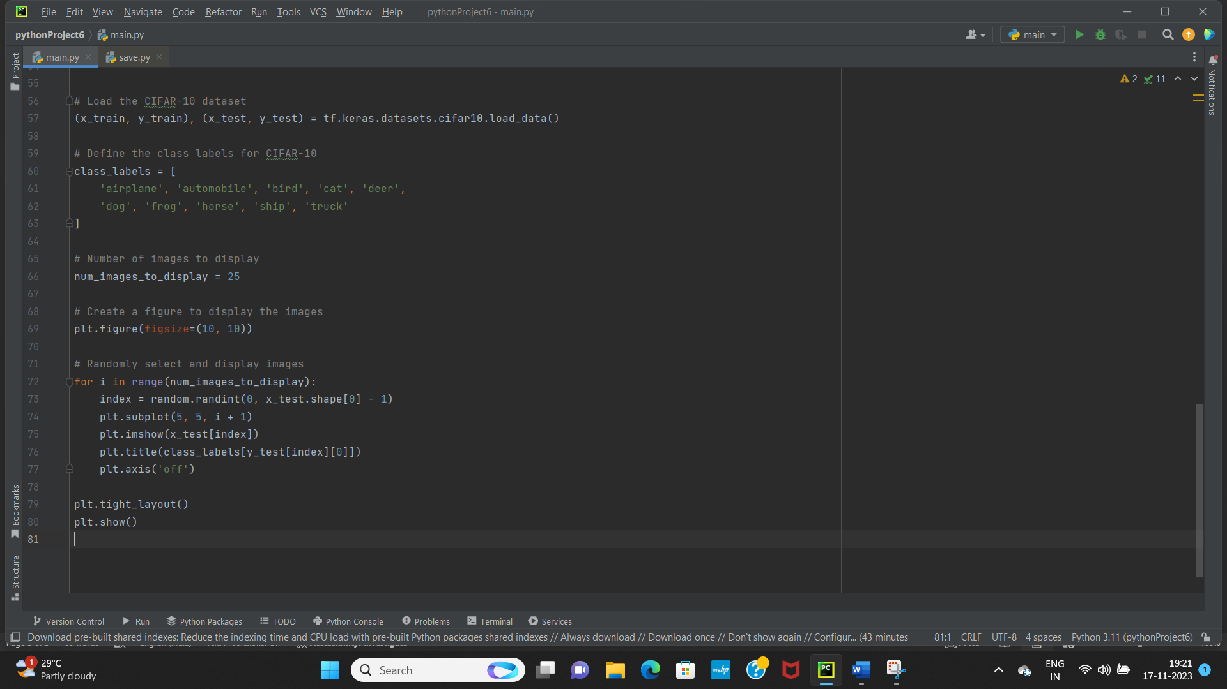

Output for Visualising 25 random images from CIFAR-10 dataset :
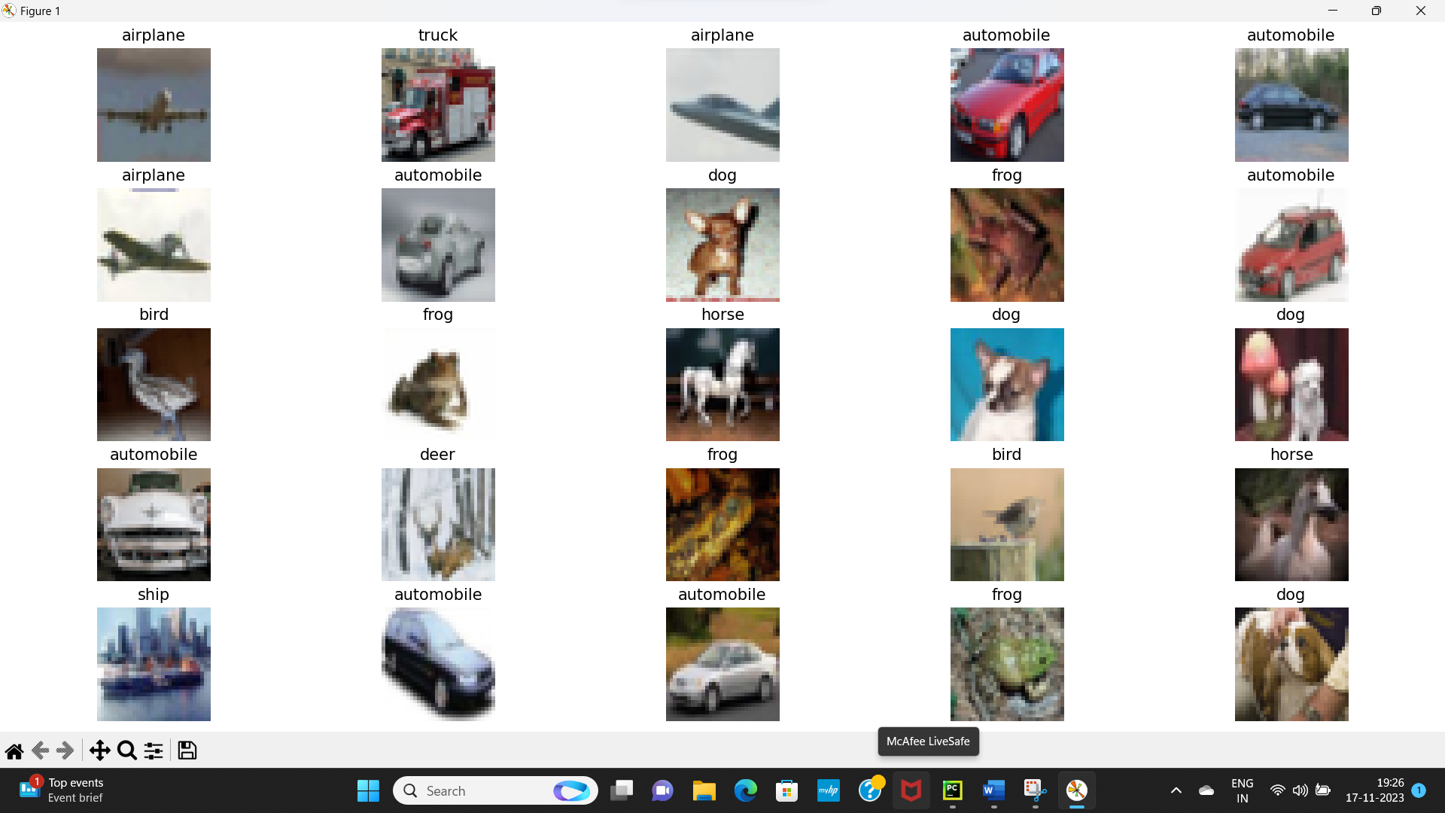

Algorithm:

1. Data Collection and Preprocessing:
- Collect labeled image dataset.
- Resize images to a fixed size.
- Normalize pixel values.
- Apply data augmentation techniques.

2. Model Architecture Design:
- Choose or design a CNN architecture.
- Configure the layers, activation functions, and pooling.
- Define dropout layers for regularization.

3. Model Training and Evaluation:
- Split the dataset into training, validation, and test sets.
- Train the CNN using training data.
- Monitor loss and accuracy during training.
- Evaluate the model on the validation and test datasets.

4. Model Deployment:
- Develop a web-based user interface for image classification.
- Implement error handling for user interactions.

5. Documentation and Reporting:
- Create comprehensive project documentation.
- Prepare user guidelines for the deployed system.
- Develop a presentation summarizing the project and results.

